# PIZZA Sales SQL Queries

**1.KPI ‘S:**

* **Total Revenue:**

select SUM(total_price) as Total_revenue from pizza_sales



* **Total Order value:**

select SUM(total_price)/ count(distinct order_id) as Total_order_value from pizza_sales;



* **Total Pizza Sold:**

select SUM(quantity) as Total_pizza_sold from pizza_sales;

T

* **Total Orders:**

select count(distinct order_id) as Total_orders from pizza_sales;



* **Average Order Sold:**

select cast(sum(quantity) as decimal(10,2)) / cast(count(distinct order_id) as decimal(10,2)) as AVG_order_sold from pizza_sales



* **Daily Trend For Total orders:**

select DATENAME(DW,order_date) as Order_day, count(distinct order_id) as Total_Order from pizza_sales

group by DATENAME(DW,order_date)

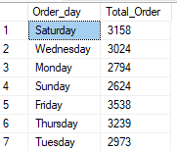

* **Monthly Trend For Total Orders:**

select datename(month,order_date) as Month_Name, count(distinct order_id) as Total_order

from pizza_sales

group by datename(month,order_date)

order by Total_order DESC

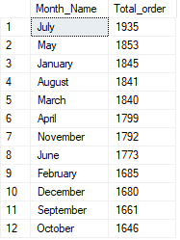

* **Percentage of Sales by Pizza Cateogory:**

select pizza_category, sum(total_price)*100/ (select sum(total_price) from pizza_sales) as Total_sales

from pizza_sales

group by pizza_category

order by Total_sales desc

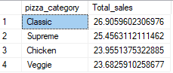

* **Percentage of sales by pizza size:**

select pizza_size,sum(total_price) as total_sales, sum(total_price)*100/ (select sum(total_price) from pizza_sales) as PCT

from pizza_sales

group by pizza_size

order by PCT desc

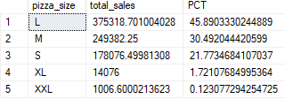

* **Top 5 best sellers by Total Revenue:**

select Top 5 pizza_name,sum(total_price) as Total_revenue

from pizza_sales

group by pizza_name

order by Total_revenue desc

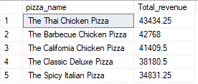

* **Bottom 5 sellers by Total Revenue:**

select Top 5 pizza_name,sum(total_price) as Total_revenue

from pizza_sales

group by pizza_name

order by Total_revenue

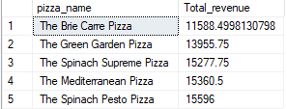

* **Top 5 sellers by Total Quantity:**

select Top 5 pizza_name,sum(quantity) as Total_quantity

from pizza_sales

group by pizza_name

order by Total_quantity desc

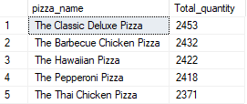

* **Bottom 5 sellers by Total quantity:**

select Top 5 pizza_name,sum(quantity) as Total_quantity

from pizza_sales

group by pizza_name

order by Total_quantity

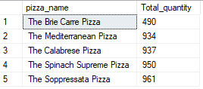

* **Top 5 sellers by Total Order:**

select Top 5 pizza_name,count(distinct order_id) as Total_orders from pizza_sales

group by pizza_name

order by Total_orders desc

